**TRIBHUWAN UNIVERSITY**

**INSTITUTE OF ENGINEERING**

**HIMALAYA COLLEGE OF ENGINEERING**



A THIRD YEAR MINOR PROJECT PROPOSAL ON

**INDUSTRIAL PARAMETERS MONITORING AND ALARM SYSTEM WITH IOT**

**PROJECT MEMBERS**

**Lokendra Rokaya (HCE076BEI004)**

**Nabin Khadka (HCE076BEI005)**

**Samyog Mahat (HCE076BEI0013)**

**DEPAREMENT OF ELECTRONICS AND COMPUTER ENGINEERING**

**HIMALAYA COLLEGE OF ENGINEERNNG**

**Chyasal, Lalitpur**

**January, 2023**

**INDUSTRIAL PARAMETERS MONITORING AND ALARM SYSTEM WITH IOT**

A THIRD YEAR MINOR PROJECT PROPOSAL

**“A THIRD MINOR PROJECT**

**REPORT SUBMITTED FOR PARTIAL FULILLMENT OF THE**

**DEGREE OF BACHELOR’S IN ELECTRONICS,**

**COMMUNIATION AND INFORMATION ENGINEERING”**

**SUBMITTEED TO**

**HIMALAYA COLLEGE OF ENGINEERING**

**DEPARTMENT OF ELECTRONICS AND COMPUTER**

**ENGINEERING**

**Chyasal, Lalitpur**

**SUBMITTED BY**

**Lokendra Rokaya (HCE076BEI004)**

**Nabin Khadka (HCE076BEI005)**

**Samyog Mahat (HCE076BEI0013)**

**January, 2023**

# ABSTRACT

This project entitled “**Industrial Parameters Monitoring and Alarm System with IOT**”. discusses about monitoring and automating the various important parameters in industry. This system is designed to prevent loss/ accident to occur through various leakages in industry and possible fire hazard. This system consists both hardware and software parts; all designed, built, programmed and integrated for monitoring various industrial parameters and automating various actions to be performed. The system will connect to the internet to share various data and control various elements of the system remotely via IOT.

The main propose of our system is to design a cheaper prototype to monitor various industrial parameters using sensors. The system also uses buzzer to warn workers if any parameter is high and might be threat to workers. Not only this but the system also shows reading in an IOT platform and some system elements can also be controlled remotely.

# TABLE OF CONTENTS

ABSTRACT I

TABLE OF CONTENTS II

LIST OF FIGURES III

ABBREVIATION IV

1. INTRODUCTION 1

1.1 BACKGROUND 1

1.2 PROBLEM STATEMENT 2

1.3 OBJECTIVE 2

1.4 SCOPE AND APPLICATIONS 3

1.4.1 SCOPE 3

1.4.2 APPLICATION 3

2. LITERATURE REVIEW 4

3. FEASIBILITY STUDY 8

3.1 TECHNICAL FEASIBILITY 8

3.2 OPERATIONAL FEASIBILITY 8

4. PROJECT METHODOLOGY 9

4.1 BLOCK DIAGRAM 9

4.2 WORKING PRINCIPLE 10

4.3 FLOWCHART 11

5. IMPLEMENTATION PLAN 12

5.1 HARDWARE SPECIFICATIONS 12

5.2 SOFTWARE SPECIFICATIONS 12

5.3 COST ESTIMATION 13

5.4 TIME ESTIMATION 14

6. DISCUSSION 15

7. EXPECTED OUTCOME. 16

REFRENCES 17

# LIST OF FIGURES

Figure 1: Block diagram of the system 9

Figure 2: Flow chart of the system 11

Figure 3: Gantt Chart 14

# ABBREVIATION

|  |  |
| --- | --- |
| CO2 | Carbon Dioxide |
| etc | et cetera |
| IMS | Industry Monitoring System |
| IOT | Internet of Things |
| i.e. | That is |
| N2 | Nitrogen |
| NO2 | Nitrogen Dioxide |
| SBC | Single Board Computer |
| WI-FI | Wireless Fidelity |

# 1. INTRODUCTION

## 1.1 BACKGROUND

Technology development is an unending process and hence it is necessary for us to be well equipped and aware of the new upgrades in technology. These technological changes have thus brought ease in daily human life. Automation has become the need of the day. Today all the data is available on the internet and web technology is growing very fast. Devices are controlled by a web controller, which is the most renowned method for web development over the world. Remote login and monitoring by building a distributed web control system with the help of web pages built in web applications is now used instead of using big server systems for monitoring managing and handling data. These kind of web control systems with IOT are characterized by: Energy Saving, Comfort, and Efficiency. Our basic objective is to apply the Internet control system to the Internet of things, such that the customers can use the application from any places around the world with the help of Internet facilities.

Regarding Industry Monitoring System (IMS) IOT is barely used. Especially in small scale industries not even any industrial parameters monitoring systems are used. The IMS system available in market are designed for all large scale industries and not focused on small and cottage industries. These IMS are also expensive; hence almost every small scale industries cannot afford them. As a result small scale industries are not well monitored.

In developing nations like Nepal most of the industries are small scale industries producing various goods and are operated and monitored manually. This is a tedious process and also consumes lot of resources and time. This also increases the risk of accident and loss. Here comes any low cost IMS as a saviour which can fit the need and requirements of small scale industries and workshops.

Various sensors can be used to take reading and monitor the readings of industrial parameters inside any industry. These sensors connected with microcontroller or SBCs to make system smart and with IOT to control system remotely and access data remotely. Sensors like gas sensors, humidity sensors, etc can be used as temperature, humidity, gases present, etc are the parameters that affect the quality of goods manufactured in an industry and also ensure workers safety.

## 1.2 PROBLEM STATEMENT

In today’s era manufacturing industries are being established like crazy. Especially in developing nations like our country Nepal manufacturing sector is just evolving and is in its early stage. The majority of industries are small scale industries. These industries are usually manually operated maintained. Various parameters of industries like pressure, humidity, temperature, level of various industrial gases, etc are barely monitored. This increases the risk of accident in the industry and also decreases the work efficiency of workers and effects them psychologically.

Most of the present systems available are manually operated, dumb and are expensive too. They don’t have remote excess either. Due to which the small scale and cottage industries can’t afford them and often ignore those systems.

The system in this era must be smart to some extent and data should be available remotely. Also the control also should be remote as internet connectivity is available everywhere these days.

## 1.3 OBJECTIVE

The objective of the project is:

* Monitoring real-time parameters of any industry where the system is installed and automating various necessary actions.

## 1.4 SCOPE AND APPLICATIONS

### 1.4.1 SCOPE

* The system can be used in various small scale and cottage industries in a developing nation like Nepal.
* It can also be used in workshops and garages for monitoring various parameters and avoiding accidents.

### 1.4.2 APPLICATION

The system can be used in wide range of industrial applications for real time industrial parameters monitoring and controlling.

* To monitor various industrial parameters.
* To avoid various accidents and injuries in industries.
* To warn workers and owner about any drastic change in various parameters.

# 2. LITERATURE REVIEW

The concept of Internet of things was introduced by the members of the radio frequency identification development community in 1999. This concept is very popular because of the growth of the mobile devices, embedded and real time communication, cloud computing and data analytics. The internet of things is a network of physical objects embedded with electronics, software and sensors having the ability to collect data from the world around us and share data across the internet. The term internet of things refers to the general idea of things, especially everyday objects that are readable, locatable, recognizable, addressable and controllable through the internet, irrespective of the communication means such as wired or wireless LAN, WAN or any means. The things or objects of real world can be People, Location (object), and Time of information (object) or Condition. These things can easily get integrated in the virtual world enabling anytime, anywhere connectivity. Now, the system architecture also includes different types of elements such as: Sensors, Communications, Cloud based capture and consolidation, Delivery of information etc.

Kavitha.B.C, Vallikannu.R . IoT based intelligent industry monitoring system. International Conference of Signal Processing and Integrated Networks, 2019. [1]

According to this, the Internet of Things (IoT) is a seemingly and fast developing ecosystem which can transform our lives in a better way in which the ‘things’ act in a way what we really want them to. IoT can build a world of automation by connecting devices, machines, and people. Industrial IoT (IIoT) is a field where IoT can contribute much to improve the productivity, reliability, efficiency thereby contributing more toward the economic growth of our country. Industrial safety and environmental responsibility goes in par with the above advancements. Advances in IoT technology have given rise to concept of connected worker which can be realized using wearable and embedded sensors by which the workers can be monitored to prevent accidents due to fluids or gas leakage, explosion, overexertion, and falls. Predictive maintenance is a most sought-after area in IIoT.

Rupali, S. Gajare, P.Mahajan .Home and industrial safety system for fire and gas leakage detection.International Research Journal of Engineering and Technology, 2018. [2]

In this work, mainly three units used in the proposed system and they are, sensor unit microcontroller unit GSM modem. For quick and efficient fire detection, flame sensor unit (LM35 temperature detector) have been placed. This unit can easily be incorporated into buzzer unit to sound a Bhattacharjee et al designed a system entitled Design and Development of a Flexible Reliable Smart Gas Detection System. This system composed of three modules; the base station, wireless sensor array and an intelligent wireless alarm unit, which offers high reliability, flexibility and uninterrupted sensing. These are achieved by incorporating various intelligent protocols like auto sensor calibration, sensor handover, wireless threshold fixation and intelligent alarm mechanism. The sensor node consists of three gas sensors, one temperature sensor and one pyro-electric infrared sensor (PIR) which enhances the sensing intelligence. The sensed data are digitized and processed by the peripheral interface controller (PIC) 16f877A based centralized embedded platform and wireless communication is achieved with a pair of 433 and 315 MHz amplitude shift keying(ask) wireless module.

Rajalakshmi.R, Vidhya. Toxic environment monitoring using sensors based on IoT. International Journal of Recent Technology and Engineering, 2019. [3]

The system planned in this paper is an excellent result for observing the toxic gases in hazardous environment for safety applications and generate the information visible anyplace within the world. The technology behind this Web of Things is advanced and is efficient solution for connecting the devices to the web and to attach the complete world of things in a network. The system deals with monitoring and controlling the environmental conditions like carbon monoxide, methane, hydrogen, LPG and flammable gases with sensors and send this data to the cloud server and draw the sensor data as pictorial statistics. The data upgraded from the enforced system is accessible within the web from anyplace within the world.

C. J. E. Onengiye M. Georgewill, “Design and Implementation of SMSBased Industrial/Homes Gas Leakage Monitoring & Detection Alarm System,” International Journal of Engineering Trends and Technology (IJETT), vol. 35, no. 9, 2016. [4]

This paper presents the design and implementation of SMS based Industrial/Homes Gas Leakage Monitoring and Detection Alarm System (SMS-GLMDAS). Gas leakage is a major concern at homes, offices, industries etc. Many homes and industries had fallen victims of inferno due to unknown Gas leakage at a hidden point. This is dangerous and requires high security to avoid life and property being destroyed. One of the preventive measures to avoid the danger associated with gas leakage is to install a gas leakage detector at vulnerable locations, hence SMS-GLMDAS is proposed. The system is designed to prevent loss/death to occur through gas leakages and hence promote safety of life and property. The system consists of hardware and software; all were designed, built, programmed, and integrated. The program codes written using Embedded C-language and system test carried out to ensure optimum performance. The time it takes the user to receive an SMS from the system control unit when Gas leakage is detected is also checked and tested for accuracy to ensure prompt delivery of the early warning message of the system.

X. Wen and Y. Fan, "Research and Design of Papermaking Industry Heat Treatment Furnace Groups Wireless Monitor System," 2008 International Seminar on Business and Information Management, 2008. [5]

In papermaking industry heat treatment furnace temperature monitor and control system, we usually adopt artificial style or conventional instrument technology to realize monitoring and controlling of heating furnace temperature. But due to fluctuation amplitude of furnace temperature is larger, which usually lead to poor production quality appearance. Aiming to this problem, we design a heat treatment furnace grouppsilas temperature intelligent monitor and control system based on single chip microprocessor and wireless communication technology. Each field controller connects with work central station by wireless communication chip nRF401. And work central station connects with upper PC through serial interface MAX232, which realizes heat treatment furnace groupspsila temperature on-line monitor and management system design efficiently. Through papermaking industry heat treatment furnace experiment monitor, system can accurately control heat furnace according to technique requirement in real-time.

# 3. FEASIBILITY STUDY

## 3.1 TECHNICAL FEASIBILITY

The proposed system is technically feasible. All the technologies required for the proposed system is available in the market. All the components i.e. sensors, modules and microcontrollers are available and are also reliable. Hence we came into the conclusion that we are completely capable of carrying out the project.

## 3.2 OPERATIONAL FEASIBILITY

The project is operationally feasible. The sensors and modules planned to be used are reliable and are being used for various proposes.

The proposed system is beneficial too as it solves the every lasting problem in small scale industries of incapability of monitoring its parameters. Here each of the various important machinery and also the working area, storage area, etc. are equipped with sensors and the user get real-time data about all the parameters. The system also uses a Wi-Fi module for a connecting the system with IOT.

# 4. PROJECT METHODOLOGY

## 4.1 BLOCK DIAGRAM

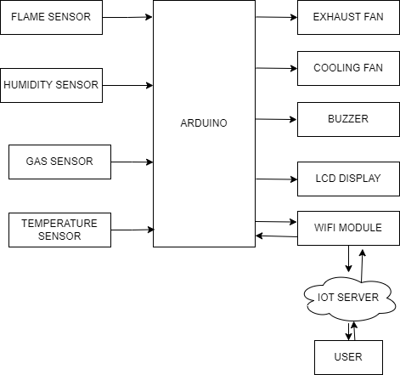

Figure 1: Block diagram of the system

In above picture is the block diagram of the overall system. Here every block on the left of main block are the sensors that will be used. Here we have gas sensors, temperature sensor, humidity sensor & flame sensor. These sensors shall read the values from the surrounding and send to Arduino microcontroller which in turn analyses the data readings and perform necessary actions. On the right we have exhaust/ventilator fan, cooling fan, buzzer, LCD display and WI-FI module. Both the fans and buzzer are atomically controlled and can also be controlled by user. the data read by the sensors are sent to IOT server via WI-FI and can be accessed by user via web-app and also the fans and buzzer can be controlled by user. The LCD monitor is updated after each action is completed i.e. reading, uploading to IOT server and accomplishing necessary action.

## 4.2 WORKING PRINCIPLE

The system is installed inside the industry or workshop buildings. The system takes continuous reading from all its sensors and keeps sending it to the IOT server using Wi-Fi module. Then the information can be accessed by user via IOT platform or web-app and certain elements like exhaust fan and cooling fans can be controlled.

First when the system starts, the sensors are initiated the sensor data are sent to the microcontroller. Those data are then analysed and sent to the IOT server using a Wi-Fi module. If the reading data is above set threshold value the buzzer initiates and the necessary action is also taken automatically. The data sent to IOT server can be accessed by a used via web app. The user can also get to control certain elements to keep things into control remotely. This in turn reduces the chance of accident.

The system uses various sensors like gas sensors, temperature sensors, humidity sensors, etc. This helps in taking all necessary parameters in industry and monitors them. Gas sensors give information about the presence of smoke and harmful gases like CO2, NO, N2, etc which are dangerous to workers working and might cause accident. The temperature and humidity level also matters inside any industry as these elements effect the quality of product. Also ignition of flames is also a risk in industry. The system has necessary sensors to address all of these problems and take readings and actions.

## 4.3 FLOWCHART

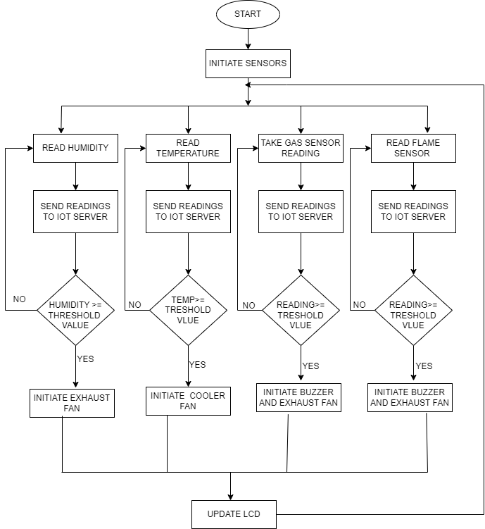

Figure 2: Flow chart of the system

# 5. IMPLEMENTATION PLAN

The system shall be implemented in such a way that it meets its objectives. The system shall be connected as per the block diagram shown in previous topic. Also the working of the system shall be as per the flowchart above. The system shall use various sensors like gas sensors, temperature sensors, humidity sensors, etc. Gas sensors give information about the presence of smoke and harmful gases like CO2, NO, N2, etc which are dangerous to workers working and might cause accident. The temperature and humidity level also matters inside any industry which is measured using temperature and humidity sensors.

## 5.1 HARDWARE SPECIFICATIONS

This system requires various hardware components to take readings, analyse it and fetch it to the server. Following are the hardware components.

* Wi-Fi module.
* Jumpers.
* Arduino.
* Flame sensor.
* Humidity sensor.
* Temperature sensor
* Gas & smoke sensors.

## 5.2 SOFTWARE SPECIFICATIONS

* Thing speak IOT platform.
* Arduino IDE.
* Arduino library.
* C language.
* Streamlit.

## 5.3 COST ESTIMATION

|  |  |  |  |  |
| --- | --- | --- | --- | --- |
| S.N | Items | | | Price(Rs) |
| 1 | Flame sensor module | | | 200 |
| 2 | Humidity sensor module | | | 650 |
| 3 | Gas sensor | | | 400 |
| 4 | Arduino mega | | | 1600 |
| 5 | Temperature sensor | | | 100 |
| 6 | Graphic LCD | | | 1500 |
| 7 | Buzzer | | | 25 |
| 8 | Tri-propeller(x2) | | | 200 |
| 9 | Esp8266(node mcu) | | | 1200 |
| 10 | Dc motor(x3) | | | 150 |
| 11 | Power supply | | 1000 | |
|  | Total | 7025 | | |

## 5.4 TIME ESTIMATION

Figure 3: Gantt Chart

# 6. DISCUSSION

This report present the design and method of development of industrial parameters monitoring and alarm system with IOT. The system shall be focusing on the monitoring of the industrial parameters and enhancing the safety of the workers in it. The idea might seem simple but implementing it in real life is actual challenge. Some features of the system are summarized below.

* **Smart:**  The system shall be smart in a sense that the system itself would be able to perform certain tasks like triggering exhaust, sending alert notifications, etc which enhances its capacity.
* **Scalable:**  The system shall be scalable as the system uses sensors and the number of sensors can be increased when required. Also some additional sensors can be added as per need. The only trouble comes with the firmware and software part which can be changed too.
* **Versatile:** The system is versatile as the system can be used in various places like warehouses, workshops, small scale industries, etc. also it can be modified as per need with the help of skilled manpower.

# 7. EXPECTED OUTCOME.

It is expected to develop the working prototype of proposed industrial parameter monitoring and alarm system with IOT. The system is expected to give real time data via IOT to user and also he/she shall be able to control certain elements of the system.

Hence the end result will be that it shall warn workers and owner about high level of any of industrial parameter of harmful gas which in turn reduces the risk and chances of accident. And increases safety and work efficiency of the workers and industry.

# REFRENCES

|  |  |
| --- | --- |
| [1] | B. K. R Vallikannu, “IEEE Xplore,” 3 2019. [Online]. Available: https://ieeexplore.ieee.org/document/8711597. |
| [2] | D. P. M. M. Rupali S. Gajare, “SEMANTICSCHOLAR,” 2018. [Online]. Available: https://www.semanticscholar.org/paper/Home-and-Industrial-Safety-System-for-fire-and-gas-Gajare-Mahajan/622ecfd20d3f094fec7fd92d30ae73ba7b3591bd. |
| [3] | J. R.Rajalakshmi, “Toxic Environment Monitoring Using Sensors,” *International Journal of Recent Technology and Engineering (IJRTE),* vol. 7, no. 6S4, 2019. |
| [4] | C. J. E. Onengiye M. Georgewill, “Design and Implementation of SMSBased Industrial/Homes Gas Leakage Monitoring & Detection Alarm System,” *International Journal of Engineering Trends and Technology (IJETT),* vol. 35, no. 9, 2016. |
| [5] | Y. F. Xinling Wen, “IEEE Xplore,” 6 2009. [Online]. Available: https://ieeexplore.ieee.org/document/5117429. |